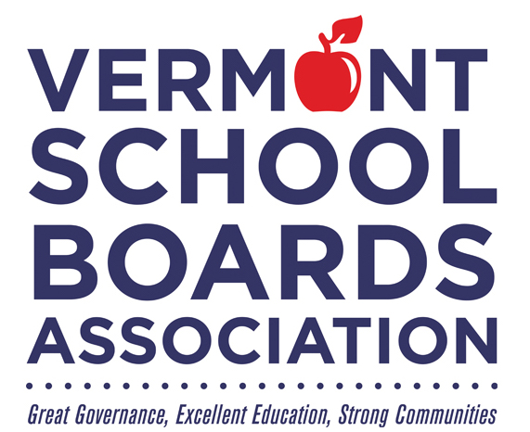

**School Board Recognition Month**

**January 2022**

*Honoring*

**_______________________________________________**

*For dedicated commitment to public education and continuing service to the children of this school district*